(E6.11) A system with a transfer function Y(s)/R(s) is $T\left(s\right)=\frac{Y\left(s\right)}{R\left(s\right)}=\frac{24(s+1)}{s^{4}+6s^{3}+2s^{2}+s+3}$
Determine the steady-state error to a unit step input. Is the system stable?
Ans.
Step input $R\left(s\right)=\frac{A}{s}$, $Y\left(s\right)=\frac{24(s+1)}{s^{4}+6s^{3}+2s^{2}+s+3}\frac{A}{s}$
- $e_{SS}=s\left[R\left(s\right)-Y\left(s\right)\right] =A\left[1-T\left(s\right)\right] =-7A$
Poles: 0, -5.67, -0.9, 0.28$±$0.714j
- The system is unstable due to right-half s-plane poles.

(E6.19) Determine whether the systems with the following characteristic equations are stable or unstable:
- $s^{3}+4s^{2}+6s+100=0$
- $s^{4}+6s^{3}+10s^{2}+17s+6=0$
- $s^{2}+6s+3=0$
Ans.
- Poles: 0.94$±$4.02j, -5.88 🡺 Unstable
- Poles: -0.44, -4.56, -0.5$±$1.66j 🡺 Stable
- Poles: -0.55, -5.5 🡺 Stable

(E6.23) A system is represented by Equation (6.22) $\dot{x}=Ax$ where
$A=\left[0 1 0 0 0 1 -8 -k -4 \right]$, characteristic polynomial is $s^{3}+4s^{2}+ks+8=0$.
Find the range of k where the system is stable.
Ans.
characteristic polynomial is $s^{3}+4s^{2}+ks+8=0$.
The Routh array is
- 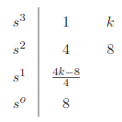 $-\frac{1}{4}\left|1 k 4 8 \right|=\frac{4k-8}{4}=k-2, -\frac{1}{k-2}\left|4 8 k-2 0 \right|=8$
- For Stability, $\frac{4k-8}{4}>0⇒k>2$

(E6.25) A closed-loop feedback system is shown in Figure E6.25. For what range of values of the parameters K and p is the system stable?
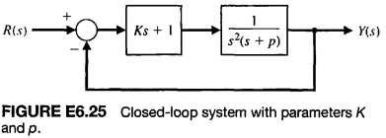
Ans.
$T\left(s\right)=\frac{sK+1}{s^{2}\left(s+p\right)+(sK+1)}$ 🡪 the characteristic equation is $s^{3}+ps^{2}+Ks+1=0$
The Routh array is
- 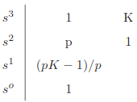$-\frac{1}{p}\left|1 K p 1 \right|=\frac{pK-1}{p}, -\frac{p}{pK-1}\left|p 1 \frac{pK-1}{p} 0 \right|=1$
- For Stability, $\frac{pK-1}{p}>0 \& p>0⇒p>0 \& K>\frac{1}{p}$

***** Important Equation in Chapter 6 *****
- Routh-Hurwitz Stability Criterion
  - All the coefficients are nonzero.
  - All the coefficients have the same sign.
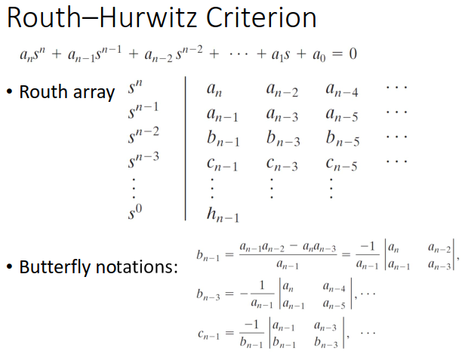
- Four Distinct Cases for Routh Array Calculation Procedure
  - Routh–Hurwitz criterion states that the number of roots with positive real parts is equal to the number of changes in sign of the first column of the Routh array.
  - Four cases: (1) No element in the first column is zero; (2) there is a zero in the first column, but some other elements of the row containing the zero inthe first column are nonzero; (3) there is a zero in the first column, and the other elements of the row containing the zero are also zero; and (4) as in the third case, but with repeated roots on the imaginary axis

